Step 1 : use the link to access online booking system : https://brfvitkalen1.sectragon.cc/Aptusportal
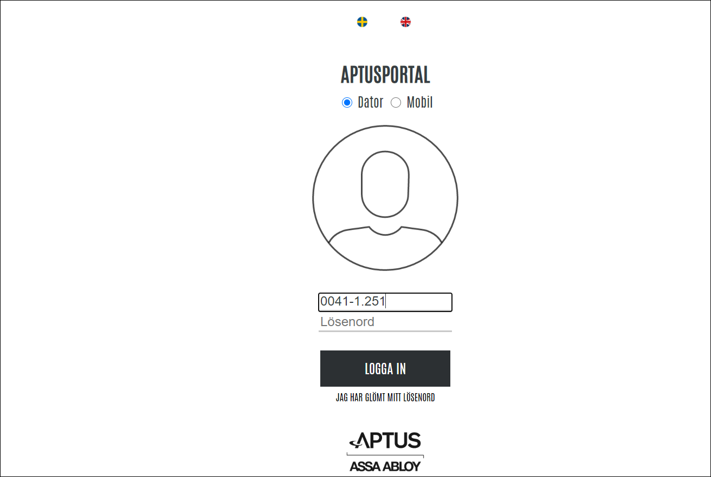

Step 2: Use the user id and password provided for your lgh. One id and password per lgh.
Eg of user id : 0041-1-xxx ( xxx is your three digit lgh number)
Click on the button “Logga In”

- If you forget your password and need a new one, please send an email to bricka@vitkalen1.se

Step 3 : This is the screen you will see when you successfully login. Click on the button “Boka” to create a booking for laundry.
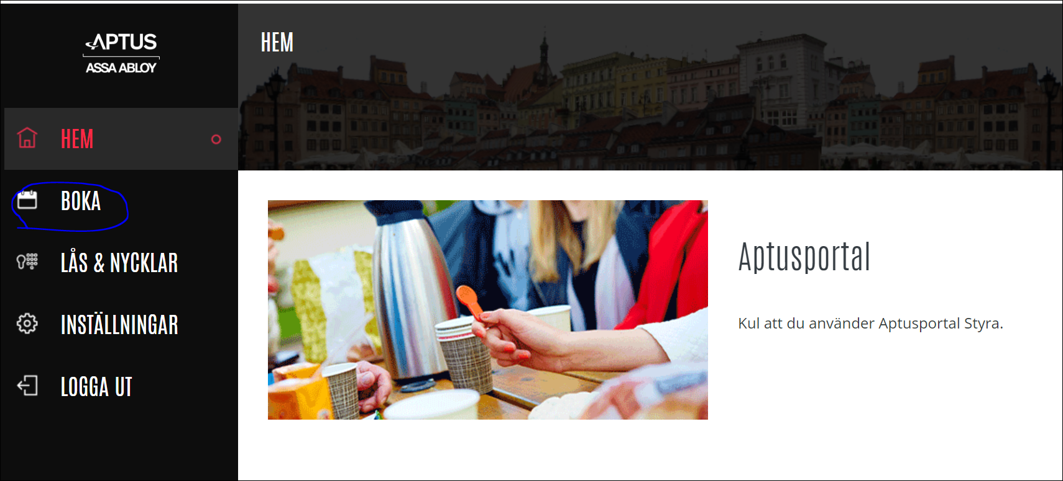

Step 4 : Click on the button “Ny Bokning”
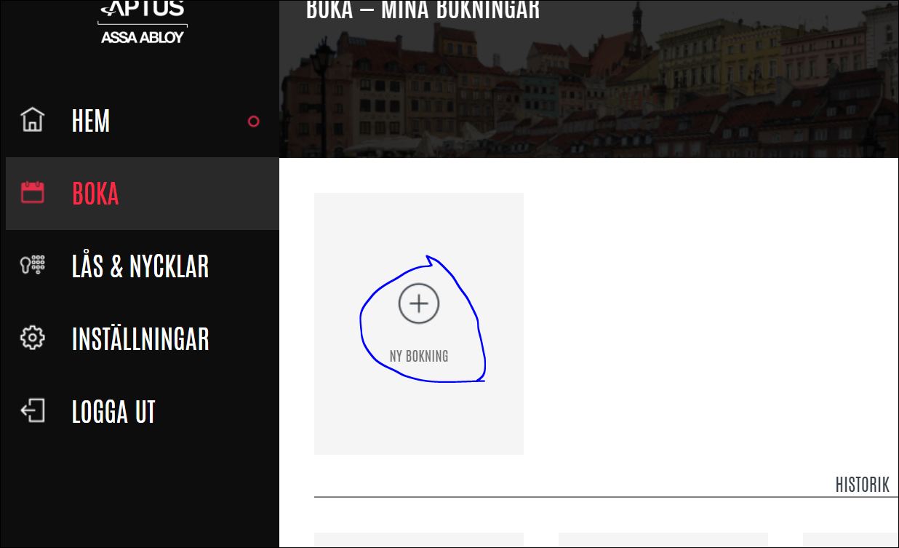
The following window will open up :
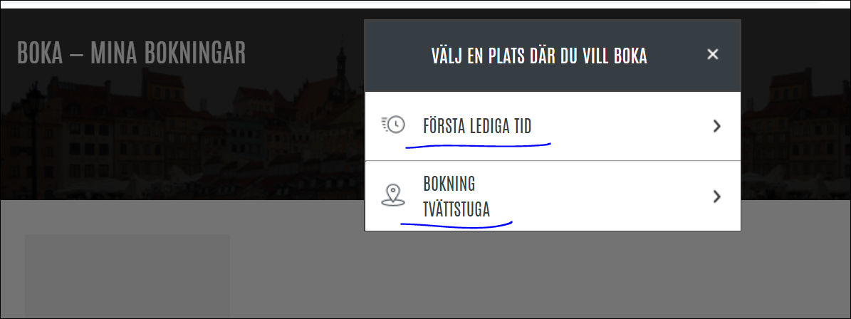

Click on “Första Lediga Tid” if you want to see the first available booking slot.
The following screen will be displayed and you can click on “Boka” button.
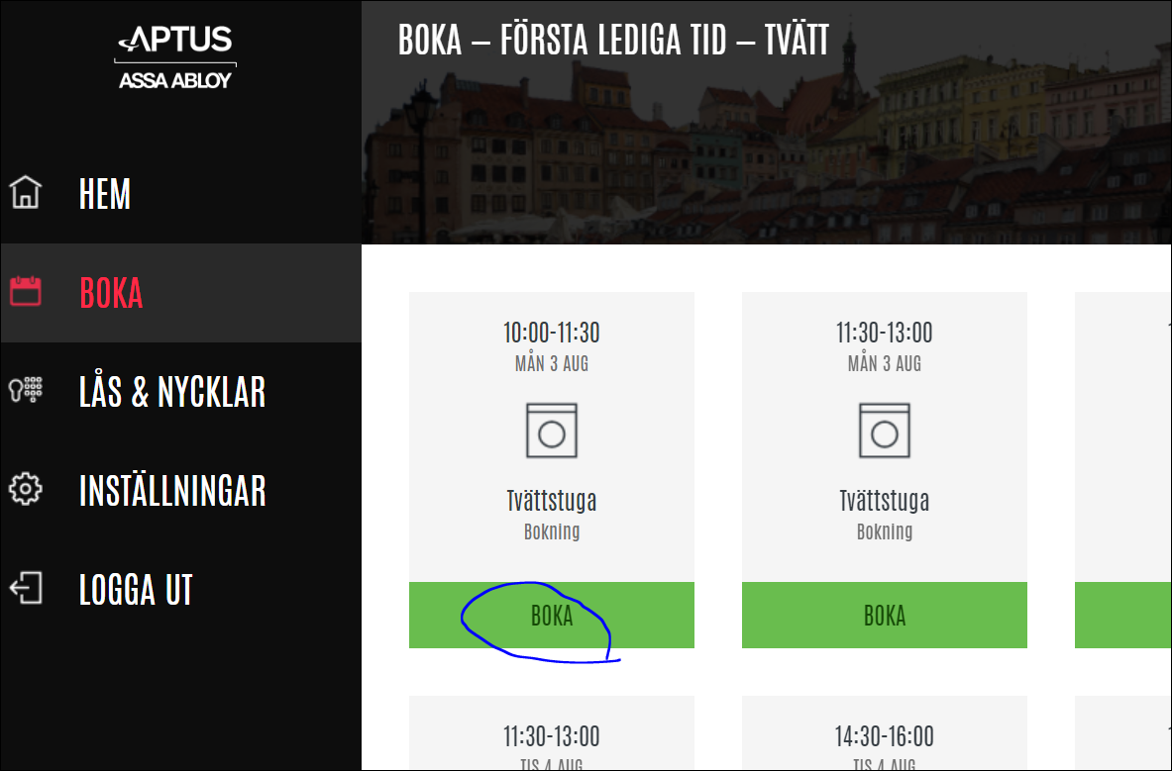

If your booking is successful, you will see the following message.
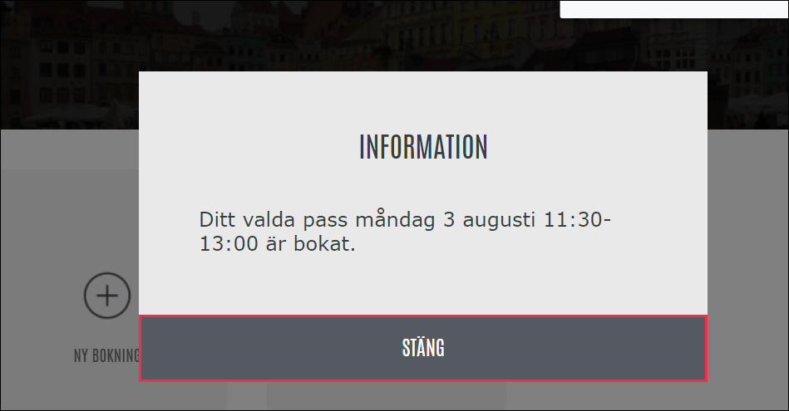

Click on “Bokning Tvättstuga” if you want to create a booking on a specific day / time in future.
The following screen will be displayed. You can then select the day you want to book in future and click on that date.
Example : I want to book on 06th august.

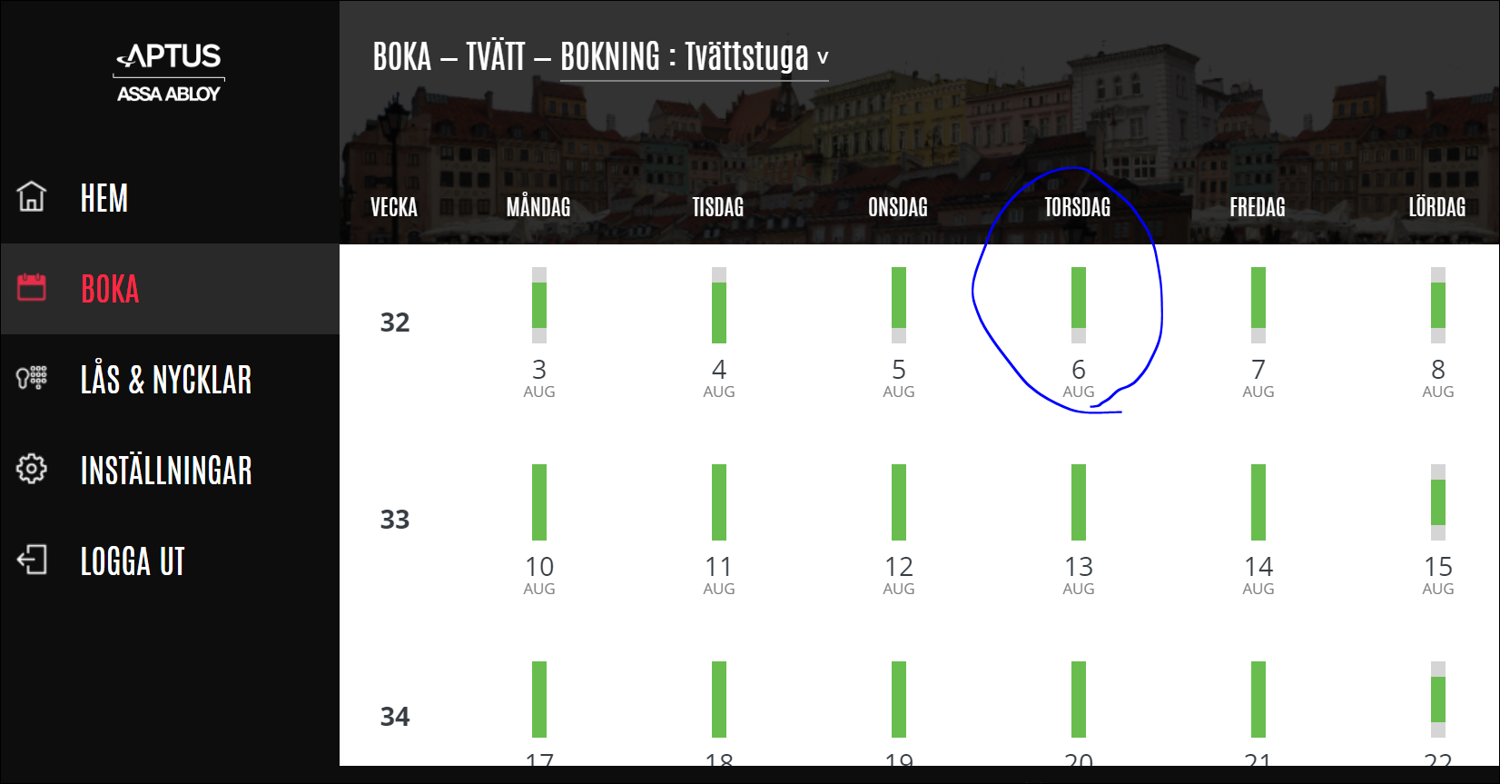
When you click on “06 Aug”, the following screen will be displayed.
The green colour slots are the available time slots for booking.
Then you can click on the time that you want to book. Example : I want to book time “08:30 -10:00”. Click on the time slot.
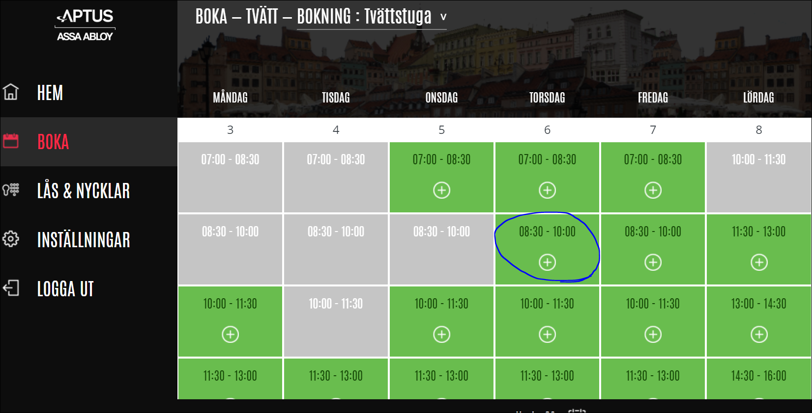

If the booking is successful, the following message will be displayed.
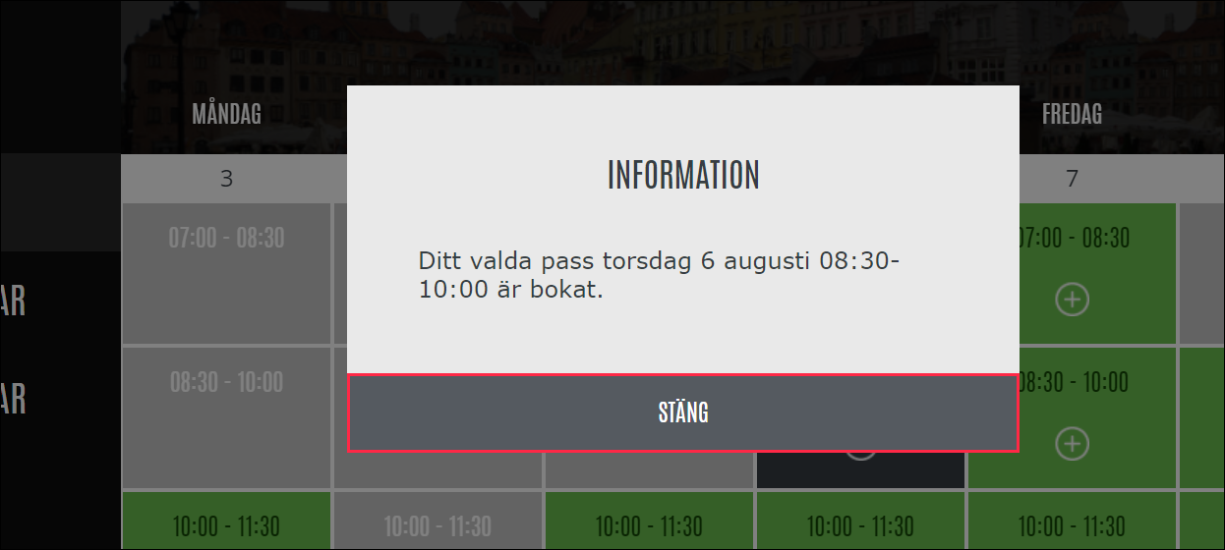

Step 5 : Cancelling a booking.
When you login and if you have a booking that you want to cancel, you can see it on the screen when you click on the button “BOKA”.
If you want to cancel the booking, click on the button “Avboka”.

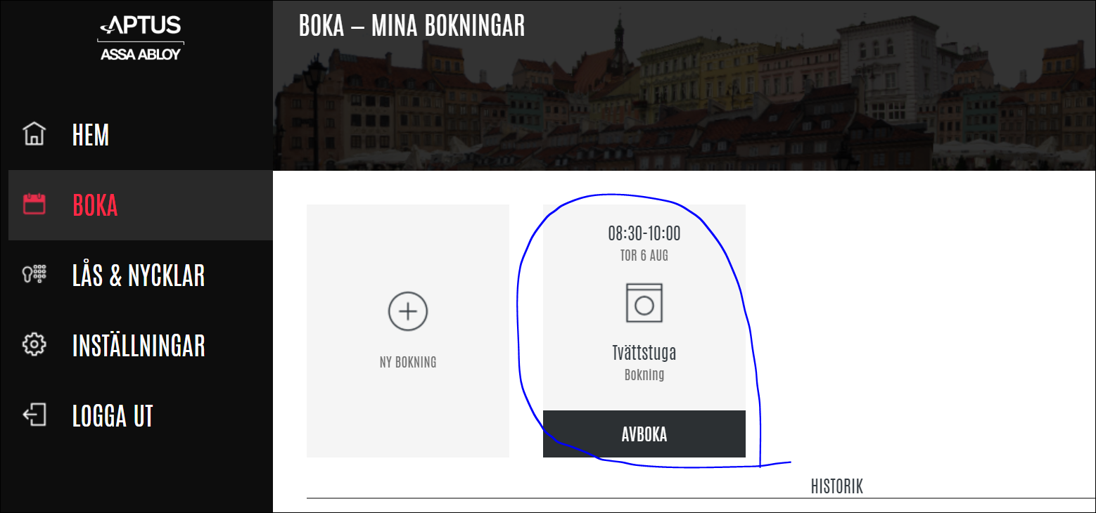
After clicking on “Avboka”, the following screen will be displayed to confirm if you want to really cancel.
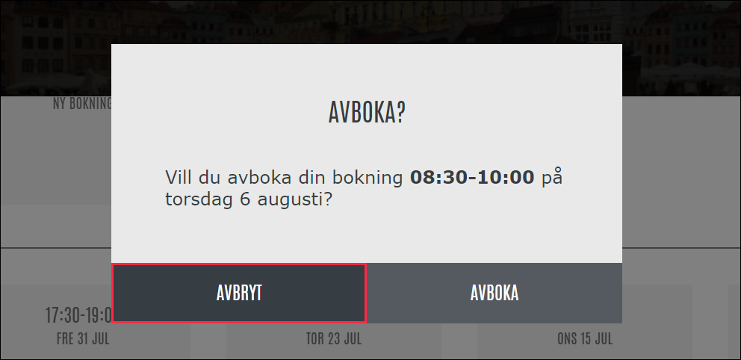
Click on “Avboka” if you want to actually cancel, if you don’t want to go ahead with cancellation, click on “Avbryt”
If the booking is successful, the following message will be displayed.
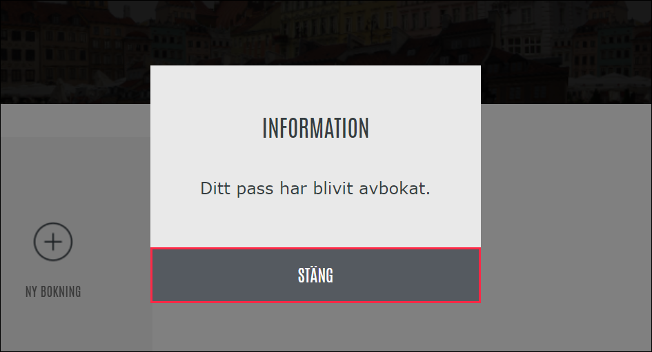
When you finished with the booking process, you can log out using the following button :

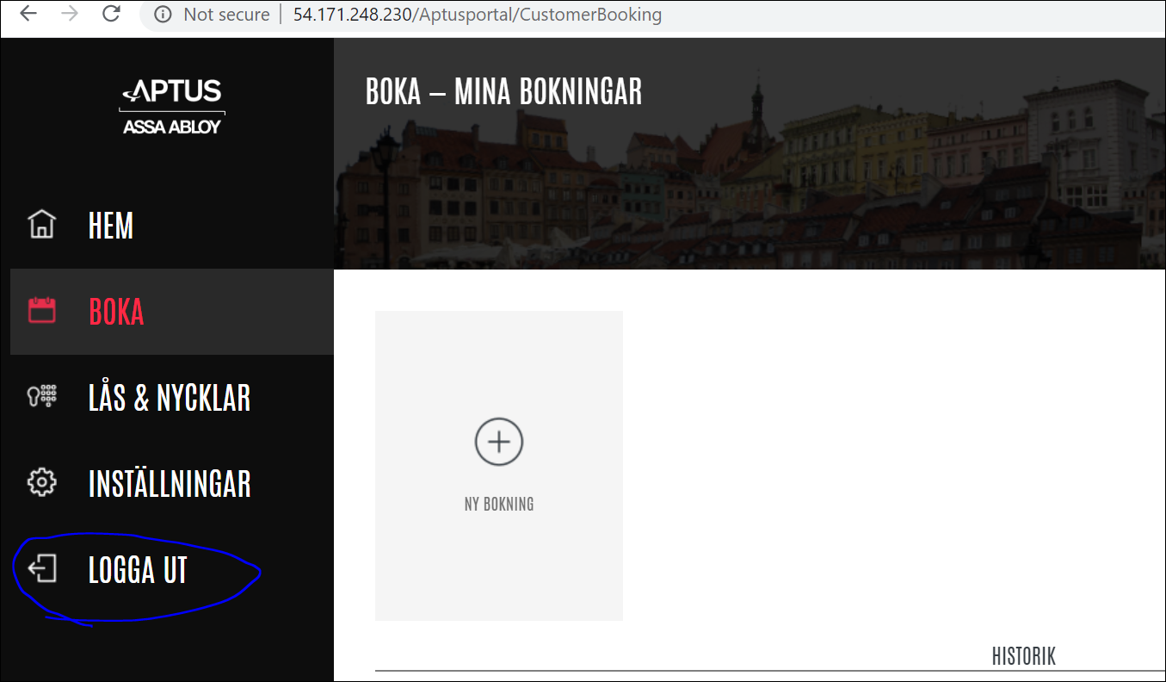

Other functions in the online interface:
- Lås & Nycklar
Not to be used. For all requests related to tags, please send email to bricka@vitkalen1.se
- Inställingar
Updating your email address so you can reset your password itself.
Click on “Epost”
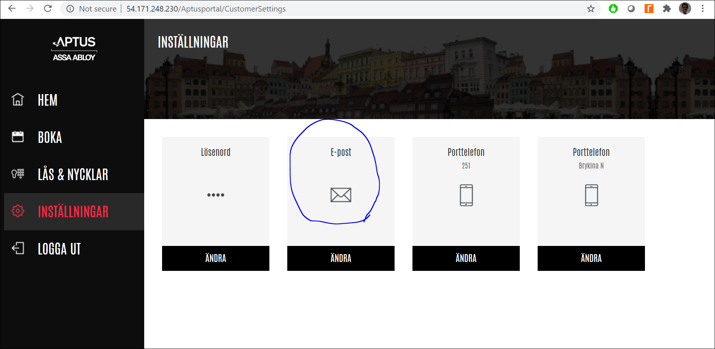

Update your email id in the space provided.
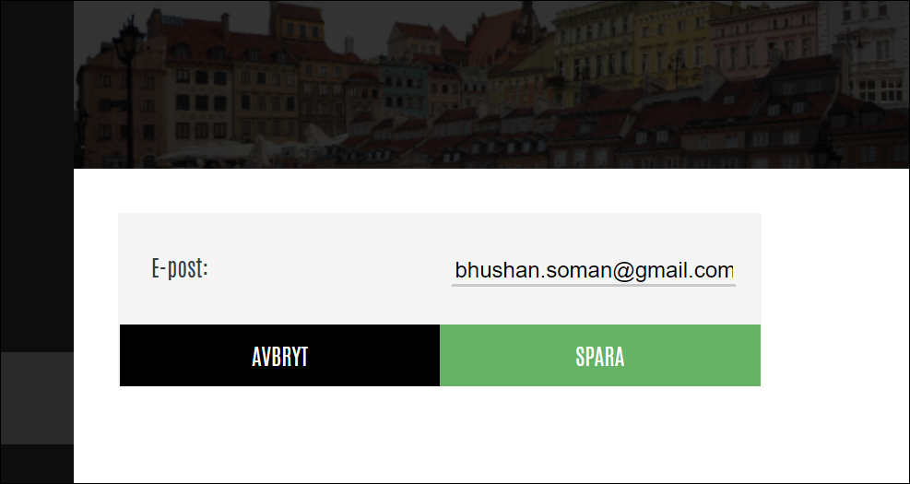

Click on “SPARA”.

Note :
- We can always book one slot at a time whether we book online or via the booking panel near the laundry.
- We are allowed to book two slots per week so that everyone gets a change to use laundry. So if you have finished booking two slots in the week, if you try to do the third booking, it will not allow and give you an error message.

